Sukkur IBA University


Data Structure Algorithm

Name: Tariq Mehmood
CMS ID: 023-23-017
Semester: 3rd
Section: E
Submitted by: Sir Riaz Hussain
Lab No: 09

Task 1 and 2
class Node{
int data;
Node left,right;
Node(int data){
this.data=data;
}
}
public class Task1{
Node root;
Node insert(Node root,int data){
if(root==null){
root=new Node(data);
return root;
}
if(root.data<data){
root.right=insert(root.right, data);
}
else if(root.data>data){
root.left=insert(root.left, data);
}
return root;
}
boolean search(Node root,int key){
if(root==null){
return false;
}
if(root.data==key){
return true;
}
if(key<root.data){
return search(root.left, key);
}
else{
return search(root.right, key);
}
}
Node delete(Node root, int key){
if(root.data>key){
root.left=delete(root.left, key);
}
else if(root.data<key){
root.right=delete(root.right, key);
}
else{
//case 1
if(root.left==null && root.right==null){
return null;
}
//case 2
if(root.left==null){
return root.right;
}
else if(root.right==null){
return root.left;
}
// Case3
Node IS=inorderSuccess(root.right);
root.data=IS.data;
root.right=delete(root.right, IS.data);
}
return root;
}
Node inorderSuccess(Node root){
while (root.left!=null) {
root=root.left;
}
return root;
}
boolean isempty(Node root){
return root==null;
}
void preOrder(Node root){
if(root==null){
return;
}
System.out.print(root.data+" ");
preOrder(root.left);
preOrder(root.right);
}
void inOrder(Node root){
if(root==null){
return;
}
inOrder(root.left);
System.out.print(root.data+" ");
inOrder(root.right);
}
void PostOrder(Node root){
if(root==null){
return;
}
PostOrder(root.left);
System.out.print(root.data+" ");
PostOrder(root.right);
}

public static void main(String[] args) {
Task1 BST=new Task1();
Node root=null;
int values[]={7,4,5,8,9,3,22,1};
for(int i=0; i<values.length; i++){
root=BST.insert(root, values[i]);
}
// root=BST.insert(root, 05);
// root=BST.insert(root, 06);
// root=BST.insert(root, 03);
BST.inOrder(root);
System.out.println();
boolean check=BST.search(root, 4);
if(check){
System.out.println("Found data");
}
else{
System.out.println("Not found ");
}
BST.delete(root, 8);
BST.inOrder(root);
System.out.println();
System.out.println("Is BST is empty "+BST.isempty(root));

System.out.println("Task 2 PreOrder, InOrder, PostOrder");
System.out.println("InOrder ");
BST.inOrder(root);
System.out.println();
System.out.println("PostOrder ");
BST.PostOrder(root);
System.out.println();
System.out.println("PreOrder ");
BST.preOrder(root);
System.out.println();
}
}

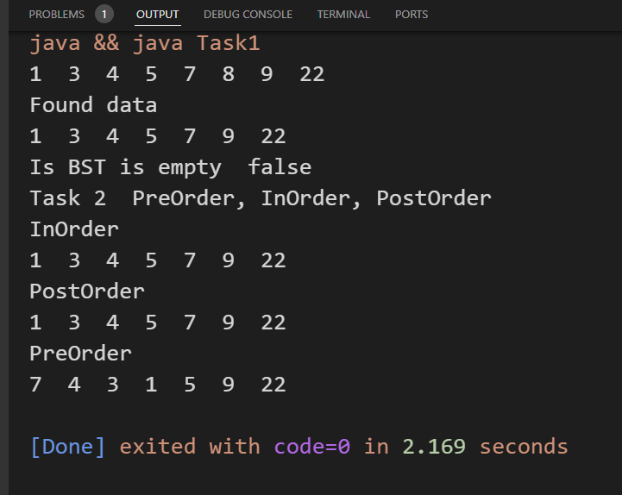

Task 3
class Node{
int data;
Node left,right;
Node(int data){
this.data=data;
}
}
public class Task2{
Node root;
Node insert(Node root,int data){
if(root==null){
root=new Node(data);
return root;
}
if(root.data<data){
root.right=insert(root.right, data);
}
else if(root.data>data){
root.left=insert(root.left, data);
}
return root;
}
Node SubtreeNode(Node root, int val){
if(root==null || root.data==val){
return root;
}
if(val<root.data){
return SubtreeNode(root.left, val);
}
return SubtreeNode(root.right, val);
}
void printSubtree(Node root){
if(root==null){
return;
}
printSubtree(root.left);
System.out.print(root.data+" ");
printSubtree(root.right);
}
void inOrder(Node root){
if(root==null){
return;
}
inOrder(root.left);
System.out.print(root.data+" ");
inOrder(root.right);
}
public static void main(String[] args) {

Task2 BST=new Task2();
Node root=null;
int values[]={7,4,5,8,9,3,22,1};
/*
7
4 9

3 5 22
1

*/
for(int i=0; i<values.length; i++){
root=BST.insert(root, values[i]);
}
BST.inOrder(root);
System.out.println();
Node result=BST.SubtreeNode(root, 4);
if(result!=null){
System.out.println("Print found Node with subtree "+result.data);
BST.printSubtree(result);

}
else{
System.out.println("Not found ");
}

}
}

